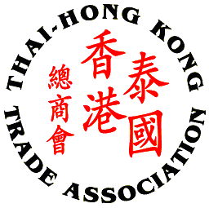
Thai – Hong Kong Trade Association

GET TOGETHER PARTY 2015 on 23rd JUNE (EVERGREEN LAUREL BANGKOK)

SPONSORSHIP FORM
Please complete this form and return to THTA at 02 343 9029
By Tuesday, June 2nd 2015

Company/Sponsor Name: __________________________________________________________
Company Address: _______________________________________________________________
______________________________________________________________________________
Contact Person’s Name: _______________________________ Position: _____________________
Tel No.: ___________________ Fax No.: __________________ Email: ______________________

Platinum Sponsor: 20,000 Baht plus VAT 7%
- 5 minutes company introduction & running company presentation
- 5 complimentary ticket to the party for Platinum sponsor’s staff (entry fee is THB 600 for additional guests)
- Booth and/or sponsor’s promotional activities
- One roller-up banner to be provided by sponsor
- Company name/logo prominently displayed on the e-invitation and the event
- Company name on all correspondence / Thank you letters
- Recognition of contribution on website

Gold Sponsor: 10,000 Baht plus VAT 7%
- 5 minutes company introduction
- Booth and/or sponsor’s promotional activities
- One roller-up banner to be provided by sponsor
- Company name/logo prominently displayed on the e-invitation and the event
- Company name on all correspondence / Thank you letters
- Recognition of contribution on website

Silver Sponsor: 5,000 Baht plus VAT 7%
- 5 minutes company introduction
- One roller-up banner to be provided by sponsor
- Company name/logo prominently displayed on the e-invitation and the event
- Company name on all correspondence / Thank you letters
- Recognition of contribution on website
***For your kind sponsorship, please attached your company logo file to display on the event***

Cheque payment to be made to: Thai - Hong Kong Trade Association
Payment Option: Direct transfer to Krung Thai Bank, Queen Sirikit National Convention Center Branch, Saving Account, A/C No. 009-1-726-336

Remark: Please fax payment slip when you have paid via direct bank transfer to 02 343 9029 or E-mail to thai-hongkong@thta.or.th

